1 .- Subneting IPV6

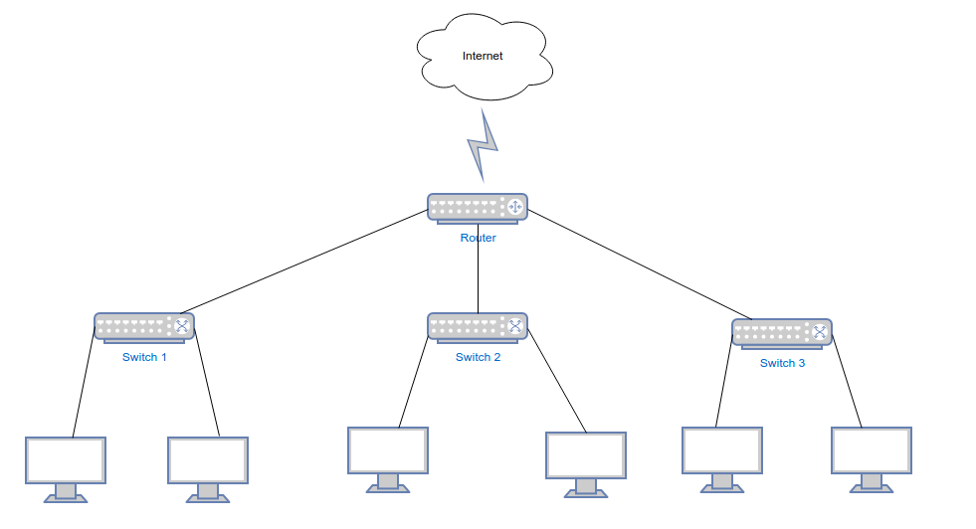
2000::1/3
FE80::0 →
FE80::FFFF:FFFF:FFFF:FFFF
FE80:0:0:1::0 →
FE80::1:FFFF:FFFF:FFFF:FFFF
FE80:0:0:2::0 → →
FE80::2:FFFF:FFFF:FFFF:FFFF
FE80::
FE80:0:0:1::
FE80:0:0:2::

Nombre SUBRED | DIRECCION DE RED | RANGO | HOSTS posibles
1 | FE80::0 | FE80::0  FE::FFFF:FFFF:FFFF:FFFF | 16¹⁶
2 | FE80:0:0:1:: | FE80:0:0:1::  FE::1:FFFF:FFFF:FFFF:FFFF | 16¹⁶
3 | FE80:0:0:2:: | FE80:0:0:2::  FE::2:FFFF:FFFF:FFFF:FFFF | 16¹⁶

